SUR140052 | Closure | FOREST - Rue des Landes, Les Bourg and Le Chene - Phase 2 | 15th Sep 14  to  22nd Oct 14
Sure (Guernsey) Ltd |  | Installation of network services.
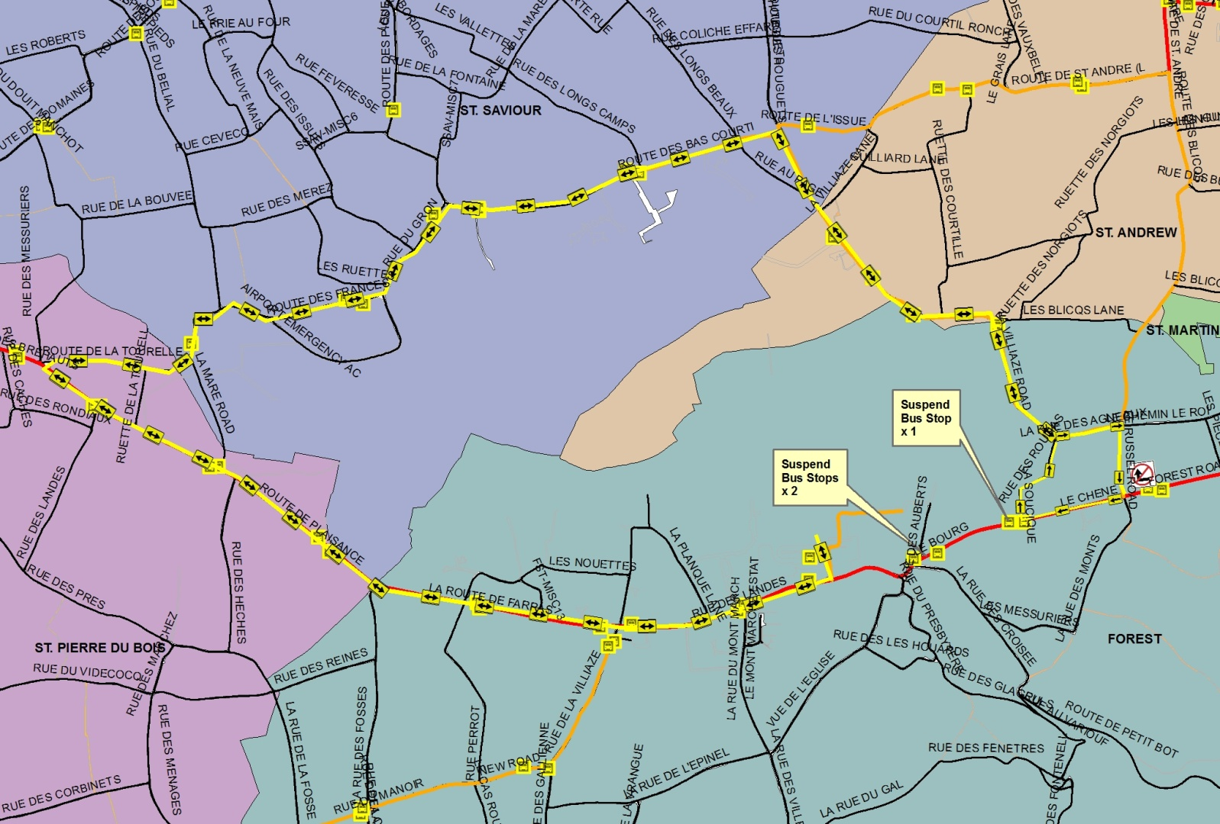
From Thursday 29th September 2014, the Forest Road will re-open as planned and works along Le Bourg (near Forest Stores) will move into phase 2. This will change the diversions for traffic travelling around the area as follows:
Diversion Eastbound towards St Martins/St Peter Port:
From Thursday 29th September the diversion for all vehicles heading east towards St Martins/St Peter Port will be as follows:
Guernsey Airport - Rue des Landes – Route des Farras – Route de Plaisance – Route de la Tourelle* – Route de Frances – Rue du Gron – Route de Bas Courtils** – La Villiaze Road – Rue des Agneaux – Russel Road – Forest Road.
* Vehicles heading east to St Martins/St Peter Port from the St Peters direction will need to turn left at the Route de Plaisance/Route de la Tourelle junction UNLESS travelling no further than the Airport/Forest Stores.
** Vehicles heading to St Peter Port can continue straight after Route de Bas Courtils heading along Route de L’Issue, Route de St Andrew (past the Little Chapel), Le Vauquiedor and Mount Row.
Diversion Westbound towards the Airport
The diversion for all vehicles heading from St Martin’s/St Peter Port (south) will be as follows:
Forest Road – Le Chene - Route de Roulias – La Villiaze Road – Route de Bas Courtils – Rue du Gron – Route de Frances – Route de la Tourelle – Route de Plaisance – Route des Farras – Rue des Landes – Guernsey Airport.
Note: There will be no right turn into Russel Rd from Forest Rd.
Scheduled Bus Services
The scheduled bus services (11, 91, 92 & 93) will follow the diversions detailed above. See attached map.
Contractors providing school bus services that are affected, are reminded to notify schools of any changes to route, pick-up or drop-off points.
All affected bus stops will be suspended
Note: The minibus shuttle service previously operating between Les Nicolles Lane and Rue Maze will cease with this changeover.
For further information on current and future road closures and diversions please consult www.iris.gov.gg.

